李京阳

|  |  |
| --- | --- |
| uc1 Load | |
| Related requirements | To log in the app with pass words |
| Iniciating actor | user |
| Actor’s goal | Check the pass words and log in |
| Participating actors | Database, Account management |
| Preconditions | Mobile phone signal is smooth |
| Flow of events:  —> user type phone number  <— Account management class check the number in the data base, if have the number, provide the pass word inputting window; else, ask the user to enter the verification code. | |

use case schema

system sequence diagram

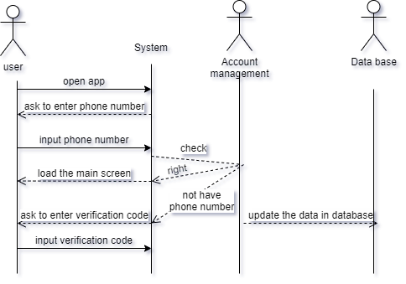

acceptance test

1. log in with right phone number and pss words. (succeed/fail)
2. First time to log in with a strange phone number:
3. Input right verification codes (succeed/fail)
4. Input wrong verification codes (succeed/fail)

王晶睿

|  |  |
| --- | --- |
| **Use Case UC-3:** | Spurring discourse and Clock in |
| **Related Requirements:** | REQ3 |
| **Initiating Actor:** | User |
| **Actor’s Goal:** | The screen pops up with spurring discourse and the punch card interface |
| **Participating Actors:** | Application, Screen |
| **Preconditions:** | APP can randomly provide spurring discourse or stored spurring discourse entered by user |
| **Postconditions:** | The punch button appears on the punch card interface |
| **Flow of Events for Main Success Scenario:** | $→$ 1.The User opens the APP $←$ 2.The screen pops up with spurring discourse and the punch card interface $←$ 3.The punch button appears on the punch card interface $→$ 4.When the user clicks the punch button, the punch card interface disappears |

|  |  |
| --- | --- |
| **Test-case Identifier:** | TC-3 |
| **Use Case Tested:** | UC-3 |
| **Pass/fail Criteria:** | The test passes if when the user opens the APP, the correct spurring discourse and the punching interface appear on the screen, and the punching interface disappears only when the user clicks the punching key. |
| **Input Data:** | Open the APP, Click the punch button |
| **Test Procedure:** | **Expected Result:** |
| Step 1. The user opens the APP without having entered his or her own spurring discourse | The screen pops with spurring discourse randomly provided by APP and the punch button appears on the punch card interface |
| Step 2. The user opens the APP with having entered his or her own spurring discourse | The screen pops with spurring discourse provided by user and the punch button appears on the punch card interface |
| Step 3. The user doesn’t click the punching key | The punch card interface doesn’t disappear |
| Step 4. The user clicks the punching key | The punch card interface disappears |

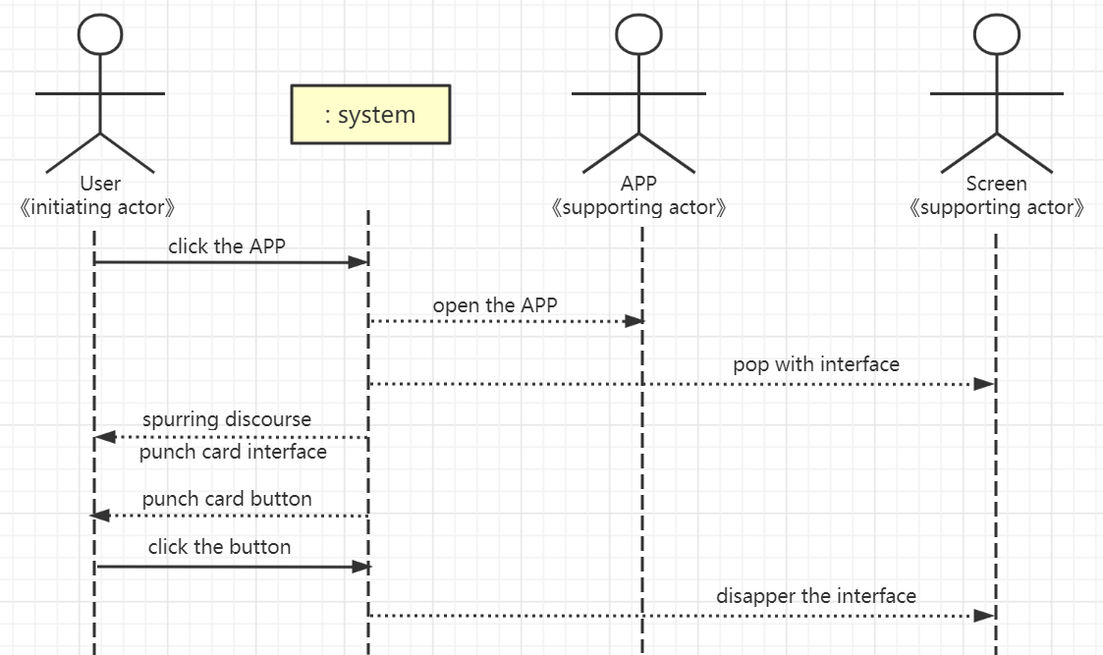

王玥莹

1. **Use case diagram**

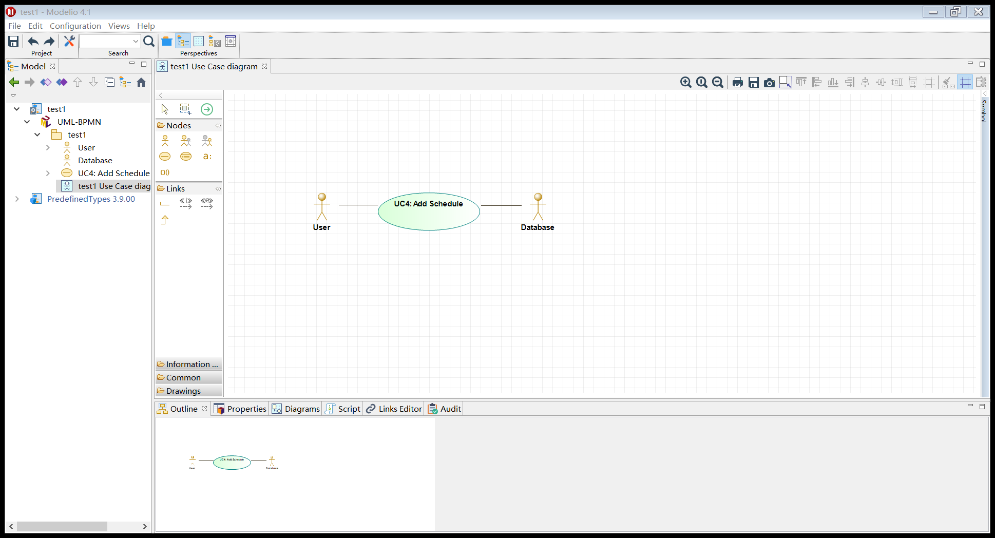

1. **Use case schema**

|  |  |
| --- | --- |
| **Use Case UC–4:** | **Add schedule** |
| **Related Requirements:** | 1. Allow to add today’s schedule 2. Allow to set an alarm as a reminder if necessary 3. Maintain a history log |
| **Initiating Actor:** | User |
| **Actor’s Goal:** | To set and save today’s schedule. To set an alarm as a reminder for schedule if necessary. |
| **Participating Actors:** | User |
| **Preconditions:** | * The user has logged in normally. * The APP has obtained the permission to use the system storage space. |
| **Postconditions:** | * The set to-do list will be displayed in the *Schedule* column. * If an alarm was set, it will be displayed in the *Clock* column and the time starts to countdown. |
| **Flow of Events for Main Success Scenario:** | |
| 🡪 | User clicks the *Add schedule* button |
| 🡨 | The App displays the interface for schedule adding |
| 🡪 | User enters the items for today’s schedule (and set alarms as reminders) |
| 🡨 | The App displays the items set by User in the *Schedule* column.  The App displays the clocks set by User (if there is) in the *Clock* column. |

1. **Acceptance test**

|  |  |
| --- | --- |
| **Test-case Identifier:** | **TC-4** |
| **Use Case Tested:** | UC-4 |
| **Pass/fail Criteria:** | The test passes if the item set is displayed in the *Schedule* column, the clock set correctly is displayed in the *Clock* column and the alarm goes off at the set time. |
| **Input Data:** | Items for the *Schedule* column, times for the *Clock* column |
| **Test Procedure:** | **Expected Result:** |
| Step 1. Enter an item for the Schedule column and invalid time for the Clock column | The APP displays *Invalid Time* to indicate failure;  records unsuccessful attempt in the database;  prompts the user to enter again |
| Step 2. Enter an item for the Schedule column and valid time for the Clock column | The APP displays S*etup Successful* to indicate success;  records successful access in the database;  the item and time can be seen in the *Schedule* column and the *Clock* column respectively;  the alarm goes off at the set time |

1. **System sequence diagram**

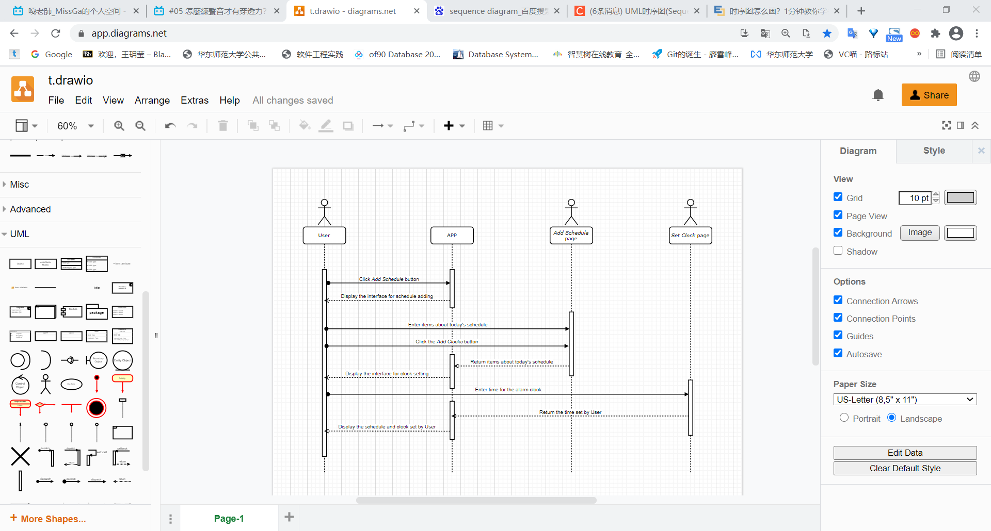

张益嘉

1、Use Case Diagram

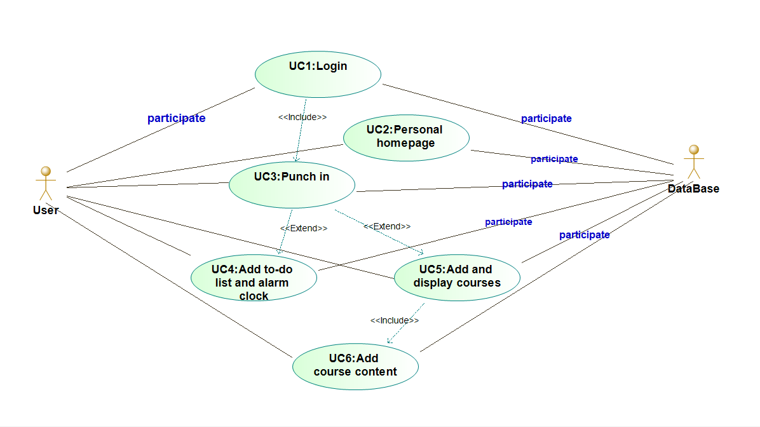

2、Use Case Schema 5

|  |  |  |
| --- | --- | --- |
| principal | Use case | Description |
| 张益嘉 | Add timetables and display courses according to needs | Users can manually add courses for easy reference at any time, or import course data for the corresponding semester through the educational administration system |

3、Acceptance Test Case

|  |  |
| --- | --- |
| Pass/fail criteria: After the user modifies the information, whether the database can be modified in time and reflected to the client  Input data: Course information to be changed | |
| Test procedure: | Except result: |
| Step 1: Did not press the submit button after making changes  Step 2: Press the submit button after making changes | The back end of the database has not changed, and it is reported to the client that the modification has not been successful  Data changes occur in the back end of the database and are fed back to the client. Course information has also changed |

4、System Sequence Diagram

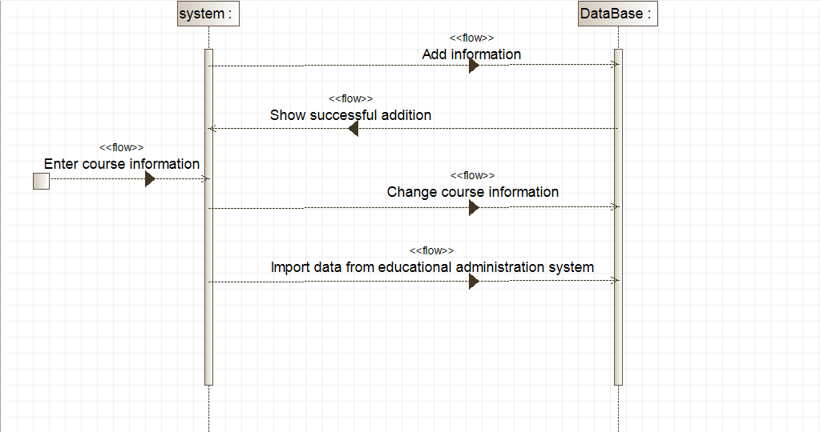

杭海培

